Name:________________________________________________
Surface Area with Blocks
Surface Area is the sum of all the areas of all the shapes that cover the surface of the object. During this activity, you will be determining the surface area of different objects.

Goal: Students will be able to find the surface area of blocks to obtain data for graphing.

Objective: Given 4 blocks, students will find the surface area of one, two, three and four blocks stacked on top of each other. Students will then collect and graph the surface area data

Materials:
- 4 Blocks
- Student worksheet with graph paper
- Ruler
- Pencil

Procedure:
Take one block from your pile and place it in front of you. You will be finding the surface area of your blocks, But what formula will you use?
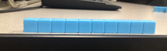
Circle the formula that you would use to solve for surface area.
Rectangular Prism = 2ab + 2bc+ 2ac Cube = 6 a ² Cylinder = 2 pi r ² + 2 pi r h

Step 1: Using the surface area formula, find the surface area of the 1 block in front of you. You are going to be using the centimeter side of the ruler. Record your answer on the table.

Step 2: Take out another block and stack them on top of each other to look like this!
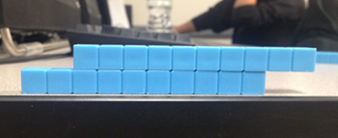

How do you think you could find the surface area of this peculiar shape above? How will the surface area formula be used ?
____________________________________________________________________________________________________________________________________________________________
Find the surface area of this object and record your answer on the table.

Step 3: Take another block out, giving you a total of 3 blocks. Stack the block on top of the other 2 blocks to make it look like this.

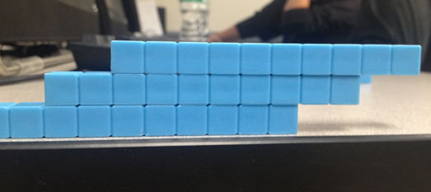

Find the surface area of this object and record your answer on the table.

Step 4: Take another block, giving you a total of 4 blocks. Stack the block on top of the other 3 blocks to make it look like this.

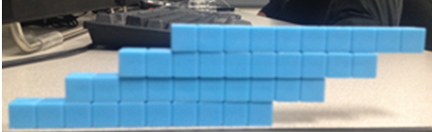

Find the surface area of this object and record your answer on the table.

Blocks | Surface Area
1
2
3
4

Step 5: Using the table, create a graph that represents the relationship between the blocks and the surface area.

What will you label your x-axis ? ______________________________
What will you label your y-axis ?_______________________________
Conclusion Questions

1.Did the number of blocks affect the surface area ? ____________________
______________________________________________________________

2.How did find the surface area of 1 block help you find the surface area of 2,3 and 4 blocks ? ____________________________________________________
________________________________________________________________

3.What does your graph show you about the surface areas ? _______________
________________________________________________________________

4.With your group, think of another peculiar shape that we could find the surface area of? ___________________________________________________
________________________________________________________________

